



**Client:** Porteous Fastener Company

**Project: Inventory Management – Item Entry/Copy Item**

**Environment:** Web-based application running on the PFC Intranet supported

by the local SQL PFCERP tables

***SECURITY***

N

Y

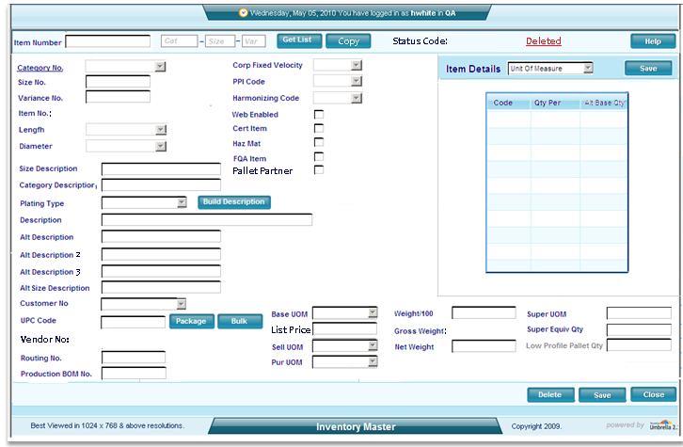

Screen 01

C:\Program Files\Microsoft Office\MEDIA\CAGCAT10\j0299125.wmf

**Basic Concept**

**Inventory Master – Item Entry / Copy Item**

**Process Flow**

* **Opening the Item Maintenance Screen**

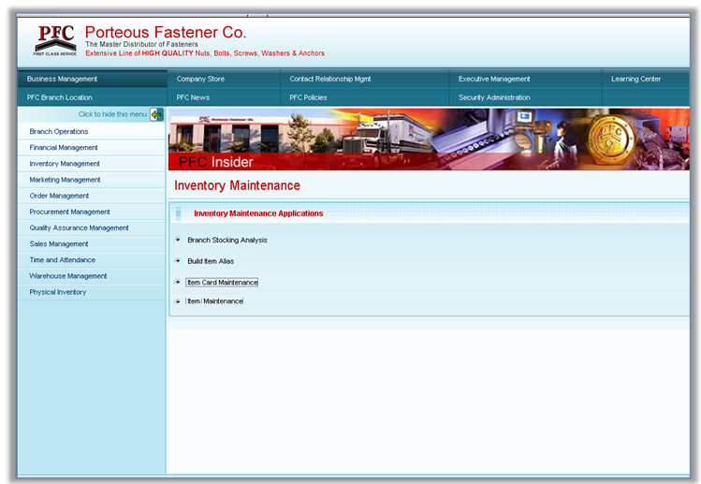

1. When Item Maintenance is selected, security is immediately checked. If the user does not pass security, display a message informing the user they are not authorized to make this selection.

**Developer Notes**: Security Codes: IMM (W), Admin (W), Maint (W) anyone of these three codes will allow the users to maintain inventory items. (we should be calling a standard routine for security)

IMM (Q) allows query only access to the screen and they cannot be changed

IMC (W), Admin(W), Maint (W) allows the user to copy a item and establish a new item master. The “Copy” button should not display if the use does not have copy security

*When the user passes security, the Item selection screen above appears. From here the user will enter the item they wish to maintain, create or List. The number is checked against the* **ItemMaster.ItemNo** table to determine if it exists. If it does not exist then a Y/N pop-up message displays stating that the item does not exist, do they want to create it?

If a List is requested using the filters then Screen 02 is displayed and the user can choose an item from the list to maintain.

Question? Should we allow the copy function from here?

**List Function**



Screen 02- The user can use this screen over and over until they click on the item they want to maintain or review.

*Developers note:*

1. *Store the pItemID that is returned from a valid item selected, it will be used throughout the maintenance session.*
2. ***Item Number*** *–* Format 00000-0000-000. When a new item number is written to the database is should use a generic **insert** statement, it is then recalled from the database using the generic **select** statement in order to populate the screen with any defaults imbedded in the database.
3. *This is the side menu for the Item Maintenance screen. This needs to be added to the main item maintenance screen (Screen 01)*

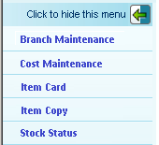

*Screen 03*

*Add:* ***Item SKU Analysis (existing function)***

**Branch Stocking Analysis (existing function – might need modification)**

**Item Notes (set as ‘Under Construction’)**

**CPR (Existing function – designed to run from Stock Status)**

**Item Builder (Existing Function – that runs from Stock Status)**

* **Entry Area** (**Maintenance, New Item and Copy item)**



**Screen 04 – Allow change or entry on the items above – If the user selects copy then copy the fields as stated below and allow maintenance – (User must have security to see the copy button – (Copy Security = IMC(W), Admin(W), and Maint(W))**

1. **Item Number –**

*When the user passes security, the Item selection screen above appears. From here the user will enter the item they wish to maintain, create or List. The number is checked against the***ItemMaster.ItemNo in the item master** table to determine if it exists. If it does not exist then a Y/N pop-up message displays stating that the item does not exist, do they want to create it**?**

If a List is requested using the filters then Screen 02 is displayed and the user can choose an item from the list to maintain.

* Reminder when adding a new item, it cannot be a duplicate and must be checked against the InventoryMaster.itemNo table. If the item already exists, return the item number value to the item selection and display message.”Item already exists. Please try again.”

**2. Category No. – Cannot be changed once a item is created – during the copy function this field is to** be prompted for the newly establish the category number (if needed) the new category should be selected from the category drop down - Allow for change only on a new or copied item**.** Once the category is set gray it out – allow the user to finish the next two field thus creating a new item number. If it is a new item and not a copy then write the item to the Item master table a retrieve the defaulted base columns and display them – if it is a copy then test the item number for duplicates and write the data as displayed – copy the UM table and pint the copied UM items to the new Item master internal itd and item number. - some of the data can be over laid as the user changes items on the screen

**3. Size No. –** Move existing size no from the copied item to entry area or as entered. Allow for change**.** (Item no. digits 6-10)

**4. Variance No. –** Move existing variance from the copied item to the entry area or allow entry. Allow for change.(Item No. digits 11-13)

**5. Size Description –** Populate the field with the data in the ItemSize column of the copied item. If thesize is changed by the user, clear the text box and allow for entry.

**6. Category Description –** Populate the field with the data in the CatDesc column of the copied item. If the Category No. is changed by the user, clear the text box and replace data with the relevant category description from the Category list.

**7. Plating Type-** Moveexisting plating type to from the copied item to the drop down. Populate the drop down with list ***InvPlatingTyp.*** The user may choose to change this data.

**8. Description –** Do not move from copied item. Description is built when user hits **Build Description** or automatically when **Save** is clicked if the entry area is blank by merging the Size Description, Category Description and Plating Type to one line.

**9. Alt Description –** Do not move from copied item but allow for user entry.

Alt Desription2 – 4 same as 9 above

1. **Customer No – copy as blank – allow the users to** Populate the field with **CustomerMaster.CustNo-CustName – like Order entry display a customer list or enter a customer number – validate it as a current from the Customer master.**
2. **UPC Code –** Do not move data from existing copied item. The UPC Code will be generated according to the user’s selection.
3. **Vendor No.** – Do not bring over from copied Item data make available to user for change.
4. **Vendor Item No.** – Do not bring over from copied Item data but do not make available to user for change.
5. **Manufacturing Policy** – Bring over from copied Item data make available to user for change.
6. **Routing No. –** Do not move from copied item. Allow for user entry.
7. **Production BOM No. –** Do not move from copied item. Allow for user entry. Must be validated against the BOM table.
8. **Flushing Method –** Bring over from copied Item data but do not make available to user for change.
9. **Corp Fixed Velocity – do not bring it over but allow the user to change**
10. **PPI Code –** Do not move from copied item **– allow entry**
11. **Harmonizing Code –** Do not move from copied item. Allow entry
12. **CHECKBOXES:** Mark according to data from copied item - allow change.

* **Web Enabled**
* **Cert Item**
* **Haz Mat**
* **FQA Item**

1. **Base UOM – Move from copied item,**
2. **Unit Price – Move from copied item.**
3. **Sell UOM – Move from copied item.**
4. **Pur UOM – Move from copied item.**
5. **Weight/ 100 – Move from copied item.**
6. **Weight 100/UOM – Move from copied item.**
7. **Gross Weight – Move from copied item.**
8. **Net Weight – Move from copied item.**
9. **Super Equiv Qty – Move from copied item.**
10. **Super Equiv UOM – Move from copied item.**
11. **Low Profile Pallet Qty – Bring over from copied Item data but do not make available to user for change**

* **Item Details**

The grid has multiple views and is controlled by the drop down shown here. They are labeled below and the grid view changes as the user chooses a different selection from the drop down. Populate the drop down with the list ***InvItemDetails.***

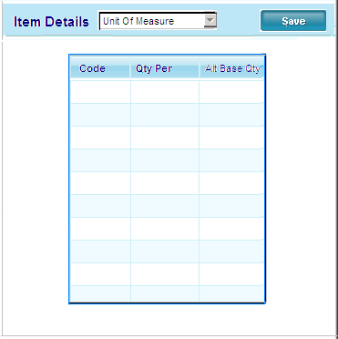

Screen 05 – During the copy function copy the

* **Unit of Measure (ItemUM table)**

Unit of measure data should be brought over from copied item and available for any necessary modifications.

1. **Code –** Bring Over from copied item
2. **Qty Per –** Bring Over from copied item
3. **Alt Base Qty –** Bring Over from copied item

* **System Defaults**

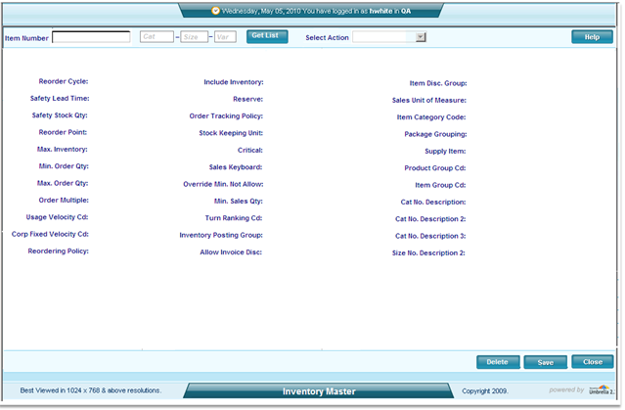

Screen 06

The following display items are defaulted by the system business rules. Each item is affiliated with data that is entered by the user or copied from an existing item. Each category listed is a selection in the drop down.

**Replenishment – (Title / Default Value)**

1. **Reorder Cycle / 1**
2. **Safety Lead Time / 0**
3. **Safety Stock Quantity / 0**
4. **Reorder Point / 0**
5. **Maximum Inventory / 0**
6. **Minimum Order Qty / 0**
7. **Maximum Order Qty / 0**
8. **Order Multiple / 0**
9. **Usage Velocity Code / 0**

**Sales – (Title / Default Value)**

1. **Reordering Policy / 0**
2. **Include Inventory / 0**
3. **Reserve / 0**
4. **Order Tracking Policy / 0**
5. **Stock Keeping Unit Exists / 0**
6. **Critical / 0**
7. **Sales Keyboard / 0**
8. **Override Min. Not Allow / 0**
9. **Min Sales Qty / 0**
10. **Turn Ranking Code / 0**
11. **Inventory Posting Group / 0**
12. **Costing Method / A**

**Catalog**

1. **Allow Invoice Disc / Y**
2. **Item Disc Group / Y**
3. **Sales Unit Of Measure / EA**
4. **Item Category Code / 0**
5. **Packaging Group / 0**
6. **Supply Item / 0**
7. **Product Group Code /0**
8. **Item Group Code / 0**
9. **Cat. No. Description / 0**
10. **Cat. No. Description Alt. 1 / 0**
11. **Cat. No. Description Alt. 2 / 0**
12. **Cat. No. Description Alt. 3 / 0**
13. **Size No. Description Alt. 1 / 0**
14. **Picture 1 Name / 0**
15. **Picture 2 Name / 0**
16. **Gen. Prod. Posting Group / 0**
17. **Inventory Posting Group**. / 0

* **Branch Maintenance – this new screen allows the user to see all branches for an item and allows specific fields to be changed and others to be seen. (See Screen 07 below)**
* **Use ItemBranch table**

|  |  |  |  |  |  |  |  |  |  |
| --- | --- | --- | --- | --- | --- | --- | --- | --- | --- |
| Loc No | Loc Name | Stk Ind | SVC | ROP | Avg Cost | **Price Cost** | **Display Repl Cost** | S/Avg Cost | Bin Cap |

**Screen 07**

**Show all stocking branches whether the IMBranch record exist or not - if a branch record does not exist for a givenBranch in the Loc name field display “No Br Record exists”.**

**Stk Ind – can be changed which could add the Branch record for the location indicated to the left of the column – if a branch record is requested copy the location 01 branch record by coping all fields as is**

**Branch Stocking Analysis Screen – call this screen from the left side menu**

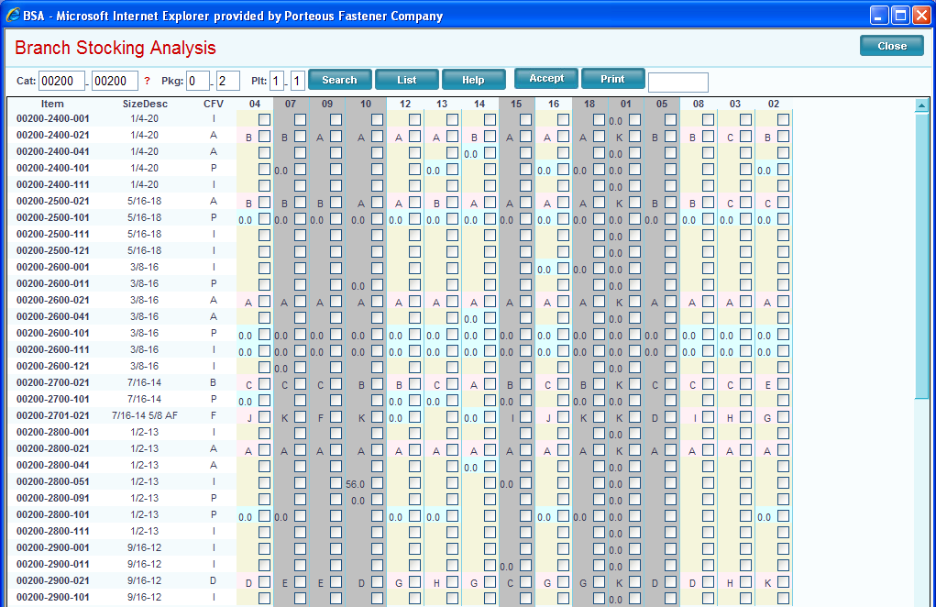

Screen 08

**Cost Maintenance (Title / Default Value)**

**1. Costing Method / A**

**2. Standard Cost Markup % /0**

**3. Unit Cost / 0**

**4. Average Cost / 0**

**5. Last Direct Cost / 0**

**6. Price/Profit Calculator / 0**

**7. Gross Margin % (Profit) / 0 – let’s leave**

**8. Competitor Price / 0 This may not be needed**

**9. Item Price Code /**

* **Item Card**

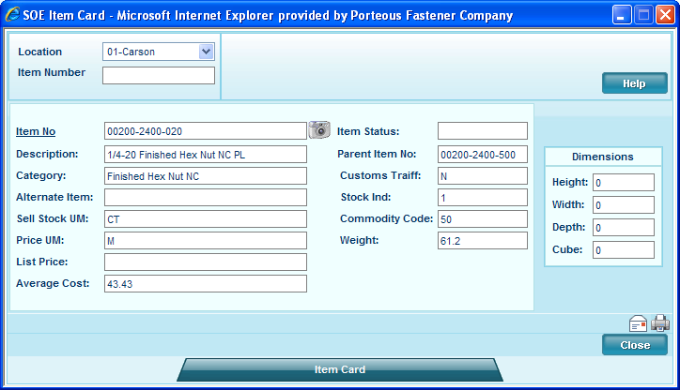

**Screen 09 – This is run from the side menu and already exist is SOE**

* **Stock Status**

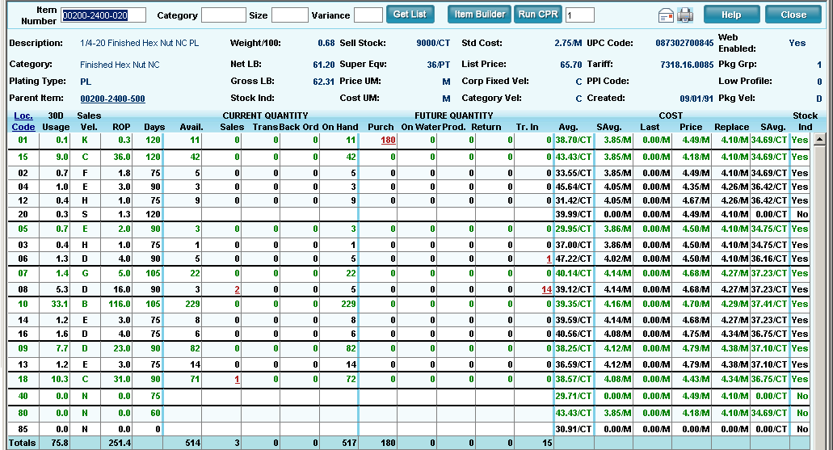

Screen 10 – this is in SOE, WO and PO so just call it from it’s standard location

**Buttons and Icons**

1. **Close** – Exit screen, clear any session variables when data is not present. If data is present
   1. **If this was a new item or cloned item in this session and the user wants to leave the screen using ‘Close’ then prompt the user and let them know they are leaving the screen without saving the newly created item** – If they choose to continue then physically delete the newly created item and UM records.
2. **Delete** – Display message: “Do you want to delete this Item?'

**Y**- Set DeleteDt and DeleteUserID(new field) and clear all fields, variables and refresh screen

**N**- Close message, continue session

1. **Save –**

**Grid View -**

**Entry Area –** Save data and build description by merging Size Description, Category Description and Plating if field is blank.

1. **Build Description –** Merge Size Description, Category Description and Plating.
2. **Package –**
3. **Bulk -**
4. **Fax, Print, Email** – Standard ERP functionality

**Database Tables**

|  |  |  |  |  |  |  |
| --- | --- | --- | --- | --- | --- | --- |
| ItemMaster | |  | |  |  |  |
| Screen Element | **Column** | | | **Dependencies** | **Defaults** | **Events** |
| n/a | pItemMasterID | | numeric(9,0) | Identity column – store for database transactions |  |  |
| Item Number | ItemNo | | varchar(20), | Can not be duplicated | none |  |
|  | AltItemNo | | varchar(20), | Can not be duplicated |  |  |
| Parent Item | ParentProdNo | | varchar(40), | Can be duplictaed |  |  |
| Description | ItemDesc | | varchar(50), | Entered field |  |  |
|  | ItemStat | | char(2) | Drop down |  |  |
|  | RecTrans | | char(2) | Y or N Default Y |  |  |
|  | Specification | | varchar(255) | Enterable |  |  |
|  | Tariff | | varchar(20), | Enterable |  |  |
| Category Description | CatDesc | | varchar(80), | Auto generated from the CategoryGroupDescription table |  |  |
| Plating | Finish | | char(4), | Auto generated during entry from the Catelogplatingtable |  |  |
| Size Description | ItemSize | | varchar(30), | Entry any 4 |  |  |
|  | PriceCat | | varchar(10), |  |  |  |
|  | PcsPerPallet | | float | Callculated (same as Sup/Eqv qty |  |  |
|  | DensityFactor | | numeric(9,0) |  |  |  |
|  | GLPostingTbl | | numeric(9,0) |  |  |  |
| Base UOM | SellStkUM | | char(5) | Use list |  |  |
|  | SellStkUMQty | | float |  |  |  |
| Pur UOM | CostPurUM | | char(5), | Use list |  |  |
| Sell UOM | PriceUM | | char(5) | Use list |  |  |
| SuperUM | SuperUM | | varchar(5) | Use list |  |  |
| Sell UOM | SellUM | | varchar(5) | Set to Price UM |  |  |
|  | SleeveUM | | varchar(5) |  |  |  |
|  | DensityUM | | char(5) |  |  |  |
|  | StkUM | | varchar(5) |  |  |  |
|  | Height | | float |  |  |  |
|  | Width | | float |  |  |  |
|  | Depth | | float |  |  |  |
|  | CubicMsr | | float |  |  |  |
| Net Weight | Wght | | float | Entered by user | Display 3 decimals |  |
| Gross Weight | GrossWght | | float | Net weight + routing weight  = Gross Weight | Display 3 decimals |  |
|  | PUMGrossWght | | float |  |  |  |
|  | PUMNetWght | | float |  |  |  |
| Weight 100 | HundredWght | | float | Weight/sellstkqty * 100 |  |  |
|  | TariffCd | | char(4) |  |  |  |
| UPC Code | UPCCd | | varchar(12), | Developed from the PKG or Bulk UPC table find the first open row (PFC item number is blank) |  |  |
|  | CommodityCd | | varchar(8), |  |  |  |
|  | SerialNoCd | | char(2) |  |  |  |
|  | FormatCd | | char(2) |  |  |  |
|  | TaxStatCd | | char(2) |  |  |  |
|  | PieceCstCd | | varchar(10) |  |  |  |
|  | AuditCostInd | | char(1) |  |  |  |
| Haz Mat | HazMatInd | | char(1) | User entered and changed |  |  |
|  | DetPartsInd | | char(1) |  |  |  |
| Web Enabled | WebEnabledInd | | char(1) | User entered and changed |  |  |
|  | CostMarkupAdder | | char(4) |  |  |  |
| Corp Fixed Velocity | CorpFixedVelocity | | varchar(10) | Enterable |  |  |
| Delete Date | DeleteDt | | datetime | Display only |  |  |
| Entry date | EntryDt | | datetime | Display only |  |  |
| Entry Id | EntryID | | varchar(50) | Display only |  |  |
| Change date | ChangeDt | | datetime | Display only |  |  |
| Change id | ChangeID | | varchar(50) | Display only |  |  |
|  | StatusCd | | char(2) |  |  |  |
| Pallet Partner | PalPtnrInd | | char(1) | Enterable |  |  |
|  | ReplacementCost | | money |  |  |  |
|  | ReplacementCostAlt | | money |  |  |  |
|  | VelocityCd | | varchar(10) |  |  |  |
|  | IMHealth | | varchar(5) |  |  |  |
|  | CatVelocityCd | | char(3) |  |  |  |
| Turn Ranking Code | Ranking | | bigint | display |  |  |
|  | ListPrice | | money |  |  |  |
| Costing Method | CostMethod | | char(2) | Display only |  |  |
|  | CommissionSchd | | char(4), |  |  |  |
|  | PackageGroup | | varchar(10), |  |  |  |
|  | BuyGroup | | int |  |  |  |
|  | BuyGroupDescription | | varchar(80), |  |  |  |
|  | ProductLine | | int |  |  |  |
|  | ProductLineDescription | | varchar(80), |  |  |  |
|  | ProductLineSort | | int |  |  |  |
|  | ItemPriceGroup | | varchar(20), |  |  |  |
|  | CertRequiredInd | | char(2), |  |  |  |
| PPI | PPICode | | varchar(30), |  |  |  |
|  | QualityInd | | char(2), |  |  |  |
| Low Profile Pallet Qty | LowProfilePalletQty | | float | = super equivalent qty |  |  |
| Diameter | DiameterDesc | | varchar(15), | enterable |  |  |
| Length | LengthDesc | | varchar(15), | enterbale |  |  |
|  | PackageVelocityCd | | Char(1) |  |  |  |
|  | ExcludeFromMRP | | Char(2) |  |  |  |
|  | BoxSize | | Varchar(10) |  |  |  |
|  | PurchaseAltMultiplier | | Numeric(6) |  |  |  |
|  | SalesAltMultiplier | | Numeric(6) |  |  |  |
|  | SubItemInd | | Char(2) |  |  |  |
|  | SellOutItemInd | | Char(2) |  |  |  |
|  | CategoryDescAlt1 | | Varchar(40) |  |  |  |
|  | CategoryDescAlt2 | | Varchar(40) |  |  |  |
|  | CategoryDescAlt3 | | Varchar(40) |  |  |  |
|  | SizeDescAlt1 | | Varchar(40) |  |  |  |
|  | HTIBidPricePerM | | Decimal(18,6) |  |  |  |

Add UserDeleteID

***Use Vendor Selection screen when >1 records to display***

|  |  |  |  |  |  |  |
| --- | --- | --- | --- | --- | --- | --- |
| ItemBranch | |  | |  |  |  |
| Screen Element | **Column** | | | **Dependencies** | **Defaults** | **Events** |
|  | **fItemMasterID** | |  |  |  |  |
| Reorder Point | **ReOrderPoint** | |  |  | 0 |  |
|  | **BreakPoint** | |  |  |  |  |
|  | **StockInd** | |  |  |  |  |
|  | **PlanningPartInd** | |  |  |  |  |
|  | **MerchandiseInd** | |  |  |  |  |
|  | **FinishGoodInd** | |  |  |  |  |
|  | **SaleabilityInd** | |  |  |  |  |
|  | **RequirePlanInd** | |  |  |  |  |
|  | **MasterSchedInd** | |  |  |  |  |
|  | **ExpenseItemInd** | |  |  |  |  |
|  | **RevLvl** | |  |  |  |  |
|  | **DesignRevLvl** | |  |  |  |  |
|  | **QtyUOM** | |  |  |  |  |
|  | **CostUOM** | |  |  |  |  |
|  | **WghtPer100UOM** | |  |  |  |  |
|  | **SuperEquivUOM** | |  |  |  |  |
|  | **SuperEquivQty** | |  |  |  |  |
|  | **OrderApprovalQty** | |  |  |  |  |
|  | **EOQ** | |  |  |  |  |
|  | **Forecast** | |  |  |  |  |
|  | **CatNo** | |  |  |  |  |
|  | **SizeNo** | |  |  |  |  |
|  | **VarNo** | |  |  |  |  |
|  | **CostBasis** | |  |  |  |  |
|  | **SellBasis** | |  |  |  |  |
|  | **CostFactor** | |  |  |  |  |
|  | **PriceFactor** | |  |  |  |  |
|  | **DiscCd** | |  |  |  |  |
|  | **FinishCd** | |  |  |  |  |
|  | **AssemblyCd** | |  |  |  |  |
|  | **MakeCd** | |  |  |  |  |
|  | **SalesVelocityCd** | |  |  |  |  |
|  | **FixedVelocityCd** | |  |  |  |  |
|  | **PackageCd** | |  |  |  |  |
|  | **PackageCostCd** | |  |  |  |  |
|  | **UnitCost** | |  |  |  |  |
|  | **AvgCost** | |  |  |  |  |
|  | **StdCost** | |  |  |  |  |
|  | **RepCost** | |  |  |  |  |
|  | **LandedCost** | |  |  |  |  |
|  | **LastLandedCost** | |  |  |  |  |
|  | **StdMtlCost** | |  |  |  |  |
|  | **StdLbrCost** | |  |  |  |  |
|  | **StdOperCost** | |  |  |  |  |
|  | **StdOtherCost** | |  |  |  |  |
|  | **FutureUnitCost** | |  |  |  |  |
|  | **LtstMatlCost** | |  |  |  |  |
|  | **LtstLbrCost** | |  |  |  |  |
|  | **LtstOperCost** | |  |  |  |  |
|  | **LtstOtherCost** | |  |  |  |  |
|  | **PrevAvgCost** | |  |  |  |  |
|  | **PrevStdCost** | |  |  |  |  |
|  | **PrevUnitCost** | |  |  |  |  |
|  | **UnitPrice1** | |  |  |  |  |
|  | **UnitPrice2** | |  |  |  |  |
|  | **ListPrice** | |  |  |  |  |
|  | **PrevPrice1** | |  |  |  |  |
|  | **FuturePrice1** | |  |  |  |  |
|  | **FuturePrice2** | |  |  |  |  |
|  | **FutureListPrice** | |  |  |  |  |
|  | **StdFixBurdenAmt** | |  |  |  |  |
|  | **StdVarBurdenAmt** | |  |  |  |  |
|  | **MatlBurdenPct** | |  |  |  |  |
|  | **LbrBurdenPct** | |  |  |  |  |
|  | **LtstFixBurdenAmt** | |  |  |  |  |
|  | **LtstVarBurdenAmt** | |  |  |  |  |
|  | **PriceEffectDt** | |  |  |  |  |
|  | **CostEffectDt** | |  |  |  |  |
|  | **LastCostDt** | |  |  |  |  |
|  | **AvgCostDt** | |  |  |  |  |
|  | **StdCostDt** | |  |  |  |  |
|  | **PrevLastCostDt** | |  |  |  |  |
|  | **PrevAvgCostDt** | |  |  |  |  |
|  | **PrevStdCostDt** | |  |  |  |  |
|  | LastMtlCostDt | |  |  |  |  |
|  | LastLbrCostDt | |  |  |  |  |
|  | UnitCostDt | |  |  |  |  |
|  | FutureCostDt | |  |  |  |  |
|  | PrevUnitCostDt | |  |  |  |  |
|  | FutUnitCostDt | |  |  |  |  |
|  | FutPrice1Dt | |  |  |  |  |
|  | FutPrice2Dt | |  |  |  |  |
|  | FutListPriceDt | |  |  |  |  |
|  | LastRecdDt | |  |  |  |  |
|  | LastOrderDt | |  |  |  |  |
|  | OrderRulesRevDt | |  |  |  |  |
|  | MosFactor | |  |  |  |  |
|  | MosModPltng | |  |  |  |  |
|  | MosModCorpFixVelocity | |  |  |  |  |
|  | MosModLocation | |  |  |  |  |
|  | LimitType | |  |  |  |  |
|  | LimitAmt | |  |  |  |  |
|  | LTSafetyStk | |  |  |  |  |
|  | WeeklyUsage | |  |  |  |  |
|  | BlanketOrderOrderPoint | |  |  |  |  |
|  | BdCode | |  |  |  |  |
|  | BdCode1 | |  |  |  |  |
|  | BdCode2 | |  |  |  |  |
|  | LbrEscalation | |  |  |  |  |
|  | MtlEscalation | |  |  |  |  |
|  | StdLbrHrs | |  |  |  |  |
|  | LtstLbrHrs | |  |  |  |  |
|  | OrderRulesRevID | |  |  |  |  |
|  | AnalystID | |  |  |  |  |
|  | BuyerID | |  |  |  |  |
|  | EntryID | |  |  |  |  |
|  | EntryDt | |  |  |  |  |
|  | ChangeID | |  |  |  |  |
|  | ChangeDt | |  |  |  |  |
|  | StatusCd | |  |  |  |  |
|  | ReplacementCost | |  |  |  |  |
|  | ReplacementCostAlt | |  |  |  |  |
|  | IMHealth | |  |  |  |  |
|  | CatVelocityCd | |  |  |  |  |
|  | Ranking | |  |  |  |  |
|  | SuggSell | |  |  |  |  |
|  | SuggSellAlt | |  |  |  |  |
|  | CurrentReplacementCost | |  |  |  |  |
|  | CurrentReplacementCostAlt | |  |  |  |  |
|  | PriceCost | |  |  |  |  |
|  | LatestReplacementCost | |  |  |  |  |
|  | PriceCostAlt | |  |  |  |  |
|  | StdCostAlt | |  |  |  |  |
|  | SuperEquivDiscPct | |  |  |  |  |
|  | ROPDays | |  |  |  |  |
|  | DirectCostAdder | |  |  |  |  |
|  | OverheadCostAdder | |  |  |  |  |
|  | IndirectCostAdder | |  |  |  |  |
|  | Capacity | |  |  |  |  |
|  |  | |  |  |  |  |

|  |  |  |  |  |  |
| --- | --- | --- | --- | --- | --- |
| Stored Procedures | |  |  |  |  |
| Procedure Name | **Description** | | **Parameters and Formulas** | | |
| pIMValidateItem | Validate Item against the InventoryMaster table using the new item number entered by the user. Check for duplicates. | |  | | |
| pIMGetCopyItem | Retrieve all necessary copied item data. | |  | | |
|  |  | |  | | |
|  |  | |  | | |

**Rules for Pop-ups:**

1. Each screen must **completely** close upon SAVE, CANCEL, CLOSE or  .
2. All events that are triggered by information in the pop-up should be executed on the destination page. Any variables that carry information from the pop-up should be cleared

